26 digital temperature module

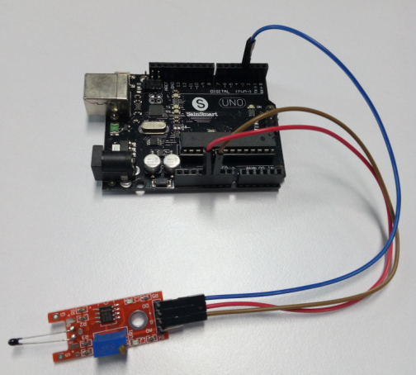

Digital temperature module and a digital interface, built-in 13 LED build a simple circuit, making

the temperature warning lamp 13 comes with digital interfaces of the LED, the digital temperature sensor connected digital three interfaces, when the digital temperature sensor senses a key signal, LED lights, otherwise off.

Routines source code:

int Led=13; //define LED Interface

int buttonpin=3; // define the digital temperature sensor interface

int val;// define numeric variables val

void setup()

{

pinMode(Led,OUTPUT); // define LED as output interface

pinMode(buttonpin,INPUT); // define digital temperature sensor output interface

}

void loop()

{

val=digitalRead(buttonpin);// digital interface will be assigned a value of 3 to read val

if(val==HIGH)// when the digital temperature sensor detects a signal, LED flashes

{

digitalWrite(Led,HIGH);

}

else

{

digitalWrite(Led,LOW);

}

}